**Children’s Fishing Event a Success**

It was a fine day for over seventy Eastern Shore youngsters who gathered Sept. 13 at the Saxis Fishing Pier. A good number of fish of various species were caught by the children, all of whom received a fishing rod and reel and a great introduction to angling under the auspices of the Eastern Shore of Virginia Anglers Club ([www.esanglersclub.org](http://www.esanglersclub.org)).

After the rigors of baiting hooks and landing fish, the children enjoyed hot dogs and soda and a presentation to the three youngsters who caught the largest fish. The free event was made possible by the Virginia Marine Resources Commission; Holt Food Services; Schmidt Baking Co.; Sea Hawk Sports Center; Utz Quality Foods; Wolff’s Sandwich Shop; and volunteers from the Eastern Shore of Virginia Anglers Club.

Shown in the first photo below are the youngsters who caught the three largest fish, Abigail Bull (left), Nathan Montgomery (center), and Caleb Perry.

Shown in the second photo is Caleb Perry with the largest fish of the day, a striped bass.

The other photo shows most of the participants in the children’s outing at Saxis.

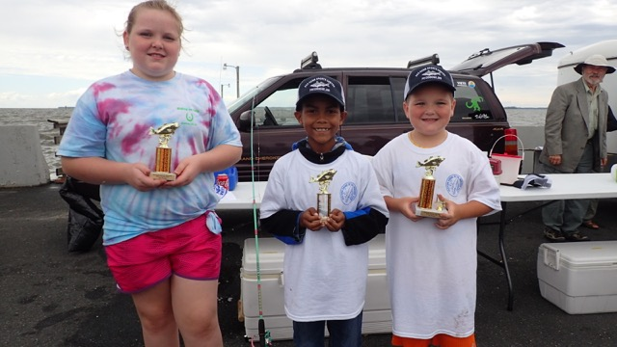

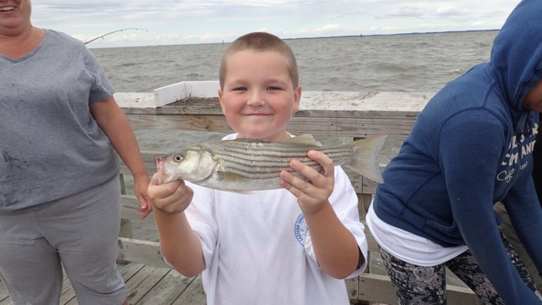

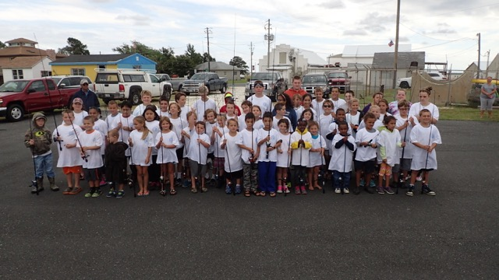

**EASTERN SHORE OF VA ANGLER’S CLUB**

**SAXIS KIDS DAY SPONSORS SEPT. 13, 2015**

VIRGINIA MARINE RESOURCES COMMISSION

HOLT FOOD SERVICES - C. L. MARSHALL

SCHMIDT BAKING COMPANY

SEA HAWK SPORTS CENTER - MATT ABELL

UTZ POTATO CHIP COMPANY

WOLFF’S SANDWICH SHOP - RON WOLFF

AND ALL OUR VOLUNTEERS